/** Model 1 =Baseline Model **/

| **Odds Ratio Estimates** | | | |  |
| --- | --- | --- | --- | --- |
| **Effect** | **Point Estimate** | **95% Wald Confidence Limits** | | **P value** |
| **age** | 0.956 | 0.929 | 0.983 | 0.0016 |
| **gender Male vs Female** | 1.995 | 1.210 | 3.289 | 0.0068 |
| **Nmon (ART Duration by Month)** | 0.995 | 0.983 | 1.006 | 0.3705 |
| **pay Self Pay + Other vs Family Member/Spouse Pay** | 0.659 | 0.357 | 1.216 | 0.1818 |
| **trans Transport to clinic: (choice=Your car) vs Transport to clinic: (choice=All Other)** | 1.771 | 0.921 | 3.406 | 0.0868 |
| **faith_act Not Active/No Religion vs Active** | 1.634 | 1.029 | 2.597 | 0.0375 |
| **family_HIV_bin none vs 1-4** | 0.620 | 0.385 | 0.997 | 0.0488 |
| **treat_support Yes vs No** | 1.991 | 1.086 | 3.650 | 0.0259 |
| **rhiv Who first recommended you to go to an HIV clinic? (Friend vs Family)** | 0.424 | 0.193 | 0.932 | 0.0321 |
| **rhiv Who first recommended you to go to an HIV clinic? (Other vs Family)** | 0.446 | 0.218 | 0.910 |
| **rhiv Who first recommended you to go to an HIV clinic? (Provider vs Family)** | 0.879 | 0.496 | 1.559 |
| **arv_start Sinikithemba (Ridge House) vs Other** | 0.503 | 0.235 | 1.077 | 0.0768 |
| **arv_train_bin 3+ vs 0-2** | 0.350 | 0.120 | 1.017 | 0.0538 |
| **current_regimen Other vs D4T** | 0.489 | 0.280 | 0.853 | 0.0418 |
| **current_regimen ZDV vs D4T** | 0.619 | 0.300 | 1.280 |
| **CO-TRIMOXAZOLE Yes vs No** | 1.625 | 0.967 | 2.730 | 0.0667 |
| **FLUCONAZOLE Yes vs No** | 4.973 | 1.287 | 19.220 | 0.0200 |
| **TBD ETHAMBUTOL Yes vs No** | 2.729 | 0.721 | 10.329 | 0.1394 |

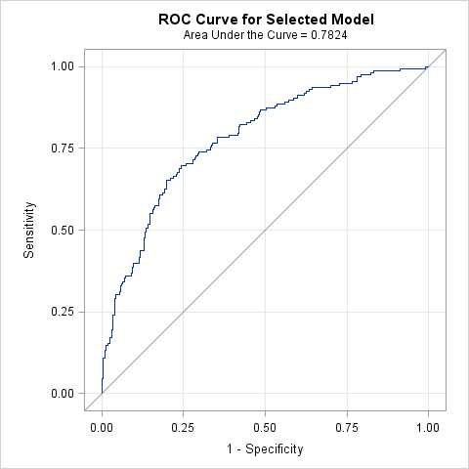

| **Hosmer and Lemeshow Goodness-of-Fit Test** | | |
| --- | --- | --- |
| **Chi-Square** | **DF** | **Pr > ChiSq** |
| 4.5794 | 8 | 0.8014 |

/** Model 2 =Demo + Socieconomic +Psycho + Symptoms + Medical History + Medications, With all suscpted variables*/

| **Odds Ratio Estimates and Profile-Likelihood Confidence Intervals** | | | | |  |
| --- | --- | --- | --- | --- | --- |
| **Effect** | **Unit** | **Estimate** | **95% Confidence Limits** | | **P value** |
| **age** | 5.0000 | 0.837 | 0.689 | 1.011 | 0.0683 |
| **gender Male vs Female** | 1.0000 | 2.262 | 1.232 | 4.195 | 0.0088 |
| **Nmon (ART Duration by Month)** | 1.0000 | 1.001 | 0.986 | 1.015 | 0.9241 |
| **edu** | 1.0000 | 1.112 | 0.958 | 1.305 | 0.1771 |
| **trans Transport to clinic: (Your car vs All Other)** | 1.0000 | 1.789 | 0.771 | 4.176 | 0.1755 |
| **clinic_feel Pleased vs Neutral** | 1.0000 | 0.448 | 0.235 | 0.850 | 0.0141 |
| **practice_safe_bin Often,Sometimes,Rarely,Never vs Always** | 1.0000 | 5.500 | 2.124 | 14.687 | 0.0005 |
| **dep_11 12+ vs 10 or 11** | 1.0000 | 3.136 | 1.693 | 5.988 | 0.0004 |
| **faith_act Not Active/No Religion vs Active** | 1.0000 | 1.722 | 0.989 | 3.016 | 0.0555 |
| **treat_support Yes vs No** | 1.0000 | 1.910 | 0.866 | 4.187 | 0.1060 |
| **family_HIV_bin none vs 1-4** | 1.0000 | 0.593 | 0.329 | 1.060 | 0.0791 |
| **symptom_fatigue Patient have symptom=Yes vs No** | 1.0000 | 2.532 | 1.382 | 4.695 | 0.0028 |
| **symptom_skin Patient have symptom=Yes vs No** | 1.0000 | 1.720 | 0.959 | 3.088 | 0.0683 |
| **symptom_diarr Patient have symptom=Yes vs No** | 1.0000 | 2.555 | 1.045 | 6.228 | 0.0385 |
| **log_cd4** | 1.0000 | 0.079 | 0.025 | 0.228 | <.0001 |
| **non_aids_condition5 Yes vs No** | 1.0000 | 0.428 | 0.209 | 0.843 | 0.0166 |
| **ses_num 2-4 vs 0-1** | 1.0000 | 0.370 | 0.147 | 0.916 | 0.1005 |
| **ses_num 5+ vs 0-1** | 1.0000 | 0.416 | 0.144 | 1.167 |
| **CO-TRIMOXAZOLE Yes vs No** | 1.0000 | 0.624 | 0.311 | 1.241 | 0.1812 |
| **FLUCONAZOLE Yes vs No** | 1.0000 | 2.636 | 0.473 | 18.614 | 0.2984 |
| **TBD ETHAMBUTOL Yes vs No** | 1.0000 | 2.800 | 0.552 | 15.190 | 0.2169 |
| **current_regimen Other vs D4T** | 1.0000 | 0.455 | 0.229 | 0.899 | 0.0755 |
| **current_regimen ZDV vs D4T** | 1.0000 | 0.649 | 0.267 | 1.553 |
| **remember_meds___7 (Media (TV/Radio)) Yes vs No** | 1.0000 | 3.519 | 1.401 | 8.962 | 0.0076 |
| **rhiv Who first recommended you to go to an HIV clinic? (Friend vs Family)** | 1.0000 | 0.311 | 0.116 | 0.793 | 0.0311 |
| **rhiv Who first recommended you to go to an HIV clinic? (Other) vs Family)** | 1.0000 | 0.376 | 0.153 | 0.892 |
| **rhiv Who first recommended you to go to an HIV clinic? (Provider vs Family)** | 1.0000 | 0.760 | 0.378 | 1.530 |
| **arv_start Sinikithemba (Ridge House) vs Other** | 1.0000 | 0.440 | 0.179 | 1.085 | 0.0732 |

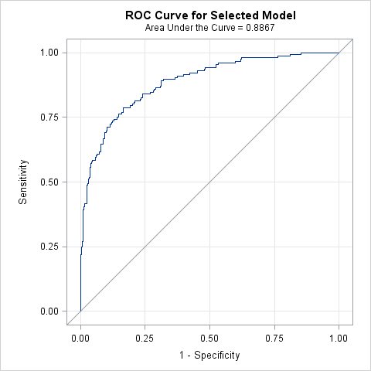

| **Hosmer and Lemeshow Goodness-of-Fit Test** | | |
| --- | --- | --- |
| **Chi-Square** | **DF** | **Pr > ChiSq** |
| 1.9557 | 8 | 0.9823 |

/** Model 3 =Demo + Socieconomic +Psycho + Accesss **/

| **Odds Ratio Estimates and Profile-Likelihood Confidence Intervals** | | | | |  |
| --- | --- | --- | --- | --- | --- |
| **Effect** | **Unit** | **Estimate** | **95% Confidence Limits** | | **P value** |
| **age** | 5.0000 | 0.865 | 0.733 | 1.017 | 0.0818 |
| **gender Male vs Female** | 1.0000 | 2.524 | 1.535 | 4.194 | 0.0003 |
| **Nmon (ART Duration by Month)** | 1.0000 | 0.988 | 0.978 | 0.998 | 0.0242 |
| **Mpr(Access)** | 0.1000 | 0.962 | 0.794 | 1.153 | 0.6786 |
| **edu** | 1.0000 | 1.111 | 0.984 | 1.267 | 0.1023 |
| **pay Self Pay + Other vs Family Member/Spouse Pay** | 1.0000 | 0.613 | 0.334 | 1.127 | 0.1136 |
| **trans Transport to clinic: (Your car vs All Other)** | 1.0000 | 1.979 | 0.995 | 3.954 | 0.0517 |
| **dep_11(depression Score) 12+ vs 10 or 11** | 1.0000 | 3.064 | 1.882 | 5.083 | <.0001 |
| **faith_act Not Active/No Religion vs Active** | 1.0000 | 1.533 | 0.957 | 2.459 | 0.0754 |
| **family_HIV_bin none vs 1-4** | 1.0000 | 0.665 | 0.415 | 1.065 | 0.0896 |
| **practice_safe_bin Often,Sometimes,Rarely,Never vs Always** | 1.0000 | 3.108 | 1.473 | 6.762 | 0.0034 |
| **treat_support Yes vs No** | 1.0000 | 1.807 | 0.987 | 3.316 | 0.0549 |
| **clinic_feel Pleased vs Neutral** | 1.0000 | 0.387 | 0.224 | 0.662 | 0.0006 |

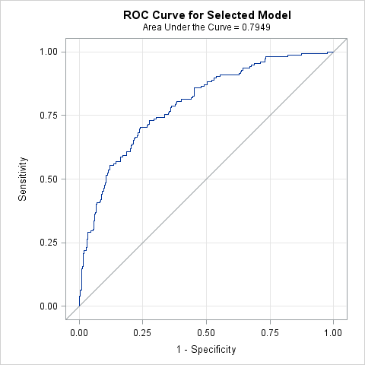

| **Hosmer and Lemeshow Goodness-of-Fit Test** | | |
| --- | --- | --- |
| **Chi-Square** | **DF** | **Pr > ChiSq** |
| 3.5185 | 8 | 0.8977 |

/** Model 4 =Demo + Psycho + Symptoms + Medical History + Medications + Adherence **/

| **Odds Ratio Estimates and Profile-Likelihood Confidence Intervals** | | | | |  |
| --- | --- | --- | --- | --- | --- |
| **Effect** | **Unit** | **Estimate** | **95% Confidence Limits** | | **P value** |
| **age** | 5.0000 | 0.807 | 0.678 | 0.951 | 0.0126 |
| **gender Male vs Female** | 1.0000 | 2.682 | 1.434 | 5.097 | 0.0022 |
| **Nmon (ART Duration by Month)** | 1.0000 | 1.007 | 0.993 | 1.022 | 0.3194 |
| **dep_11(Depression Score) 12+ vs 10 or 11** | 1.0000 | 2.689 | 1.432 | 5.180 | 0.0025 |
| **faith_act Not Active/No Religion vs Active** | 1.0000 | 1.854 | 1.048 | 3.315 | 0.0351 |
| **family_HIV_bin none vs 1-4** | 1.0000 | 0.488 | 0.268 | 0.877 | 0.0173 |
| **practice_safe_bin Often,Sometimes,Rarely,Never vs Always** | 1.0000 | 5.905 | 2.151 | 16.771 | 0.0007 |
| **treat_support Yes vs No** | 1.0000 | 1.699 | 0.773 | 3.703 | 0.1829 |
| **clinic_feel Pleased vs Neutral** | 1.0000 | 0.517 | 0.269 | 0.994 | 0.0472 |
| **symptom_fatigue Patient have symptom=Yes vs No** | 1.0000 | 2.471 | 1.339 | 4.603 | 0.0040 |
| **symptom_diarr Patient have symptom=Yes No** | 1.0000 | 2.026 | 0.772 | 5.234 | 0.1460 |
| **symptom_sad Patient have symptom=Yes vs No** | 1.0000 | 1.401 | 0.757 | 2.584 | 0.2799 |
| **symptom_skin Patient have symptom=Yes vs No** | 1.0000 | 2.011 | 1.093 | 3.723 | 0.0250 |
| **log_cd4** | 1.0000 | 0.078 | 0.026 | 0.206 | <.0001 |
| **non_aids_condition5 (Lipodystrophy) Yes vs No** | 1.0000 | 0.611 | 0.299 | 1.211 | 0.1657 |
| **arv_start Sinikithemba (Ridge House) vs Other** | 1.0000 | 0.487 | 0.191 | 1.264 | 0.1340 |
| **rhiv Who first recommended you to go to an HIV clinic? (Friend vs Family)** | 1.0000 | 0.279 | 0.096 | 0.762 | 0.0199 |
| **rhiv Who first recommended you to go to an HIV clinic? (Other vs Family)** | 1.0000 | 0.350 | 0.141 | 0.834 |
| **rhiv Who first recommended you to go to an HIV clinic? (Provider vs Family)** | 1.0000 | 0.806 | 0.392 | 1.660 |
| **current_regimen Other vs D4T** | 1.0000 | 0.484 | 0.240 | 0.970 | 0.1201 |
| **current_regimen ZDV vs D4T** | 1.0000 | 0.699 | 0.286 | 1.680 |
| **ses_num 2-4 vs 0-1** | 1.0000 | 0.383 | 0.136 | 1.053 | 0.1734 |
| **ses_num 5+ vs 0-1** | 1.0000 | 0.470 | 0.149 | 1.446 |
| **remember_meds___7 (TV/Radio) Yes vs No** | 1.0000 | 3.363 | 1.336 | 8.558 | 0.0101 |
| **TBD ETHAMBUTOL Yes vs No** | 1.0000 | 3.606 | 0.580 | 23.275 | 0.1712 |
| **Pill (Adherence)** | 0.1000 | 0.753 | 0.576 | 0.968 | 0.0330 |

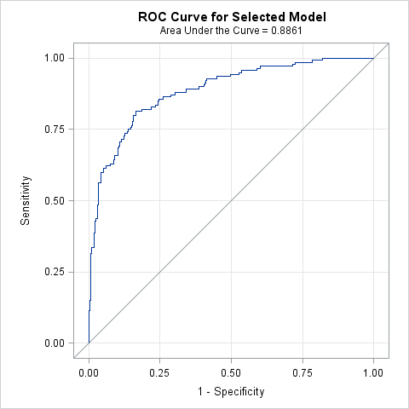

| **Hosmer and Lemeshow Goodness-of-Fit Test** | | |
| --- | --- | --- |
| **Chi-Square** | **DF** | **Pr > ChiSq** |
| 8.1917 | 8 | 0.4150 |

/** Model 5 =Demo + Socieconomic +Psycho + Symptoms + Medical History + Medications + Access + Adherence **/

| **Odds Ratio Estimates and Profile-Likelihood Confidence Intervals** | | | | |  |
| --- | --- | --- | --- | --- | --- |
| **Effect** | **Unit** | **Estimate** | **95% Confidence Limits** | | **P value** |
| **age** | 5.0000 | 0.860 | 0.702 | 1.048 | 0.1404 |
| **gender Male vs Female** | 1.0000 | 2.416 | 1.272 | 4.657 | 0.0075 |
| **Nmon (ART Duration)** | 1.0000 | 1.008 | 0.993 | 1.023 | 0.2936 |
| **Pill (Adherence)** | 0.1000 | 0.763 | 0.583 | 0.981 | 0.0418 |
| **Edu** | 1.0000 | 1.108 | 0.955 | 1.301 | 0.1896 |
| **trans Transport to clinic: (Your car vs All Other)** | 1.0000 | 2.034 | 0.817 | 5.086 | 0.1265 |
| **dep_11 (Depression Score) 12+ vs 10 or 11** | 1.0000 | 3.021 | 1.583 | 5.944 | 0.0010 |
| **faith_act Not Active/No Religion vs Active** | 1.0000 | 1.802 | 1.009 | 3.249 | 0.0478 |
| **family_HIV_bin none vs 1-4** | 1.0000 | 0.500 | 0.272 | 0.907 | 0.0236 |
| **practice_safe_bin Often,Sometimes,Rarely,Never vs Always** | 1.0000 | 5.023 | 1.821 | 14.259 | 0.0020 |
| **treat_support Yes vs No** | 1.0000 | 1.783 | 0.803 | 3.929 | 0.1515 |
| **clinic_feel Pleased vs Neutral** | 1.0000 | 0.509 | 0.260 | 0.996 | 0.0476 |
| **symptom_fatigue Patient have symptom=Yes vs No** | 1.0000 | 2.470 | 1.319 | 4.668 | 0.0049 |
| **symptom_diarr Patient have symptom=Yes vs No** | 1.0000 | 2.079 | 0.802 | 5.287 | 0.1262 |
| **symptom_sad Patient have symptom=Yes vs No** | 1.0000 | 1.409 | 0.756 | 2.615 | 0.2768 |
| **symptom_skin Patient have symptom=Yes vs No** | 1.0000 | 1.992 | 1.078 | 3.696 | 0.0278 |
| **log_cd4** | 1.0000 | 0.078 | 0.026 | 0.217 | <.0001 |
| **non_aids_condition5(Lipodystrophy) Yes vs No** | 1.0000 | 0.608 | 0.296 | 1.209 | 0.1639 |
| **rhiv Who first recommended you to go to an HIV clinic? (Friend vs Family)** | 1.0000 | 0.266 | 0.090 | 0.734 | 0.0234 |
| **rhiv Who first recommended you to go to an HIV clinic? (Other vs Family)** | 1.0000 | 0.397 | 0.159 | 0.957 |
| **rhiv Who first recommended you to go to an HIV clinic? (Provider vs Family)** | 1.0000 | 0.855 | 0.417 | 1.765 |
| **current_regimen Other vs D4T** | 1.0000 | 0.435 | 0.214 | 0.879 | 0.0634 |
| **current_regimen ZDV vs D4T** | 1.0000 | 0.691 | 0.280 | 1.684 |
| **ses_num 2-4 vs 0-1** | 1.0000 | 0.378 | 0.135 | 1.052 | 0.1755 |
| **ses_num 5+ vs 0-1** | 1.0000 | 0.419 | 0.131 | 1.305 |
| **remember_meds___7(TV/Radio) Yes vs No** | 1.0000 | 3.681 | 1.443 | 9.480 | 0.0064 |
| **FLUCONAZOLE Yes vs No** | 1.0000 | 3.006 | 0.482 | 22.143 | 0.2563 |
| **TBD ETHAMBUTOL Yes vs No** | 1.0000 | 3.025 | 0.499 | 19.212 | 0.2308 |

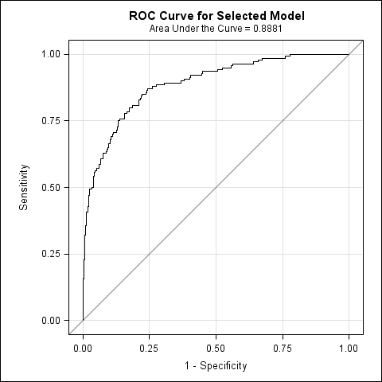

| **Hosmer and Lemeshow Goodness-of-Fit Test** | | |
| --- | --- | --- |
| **Chi-Square** | **DF** | **Pr > ChiSq** |
| 2.6794 | 8 | 0.9528 |